**We have developed two new products under the Make In India Initiative**

1. **New H Bayonet Developed for Zero Leakage System-Patent obtained in Feb 2024**
2. **SMART PRE INSULATED FLAT OVAL/ HEXAGON DUCTS: Patent awaited**

**The New Smart PID(Pre Insulated Ducting) Systems with connecting flanges and New H bayonet as being used is a replacement of conventional GI Ducts with Insulation and other PID Systems.**

**New H Bayonet Developed for Zero Leakage System:**

H Bayonet – The chances of leakages in Pre Insulated Ducting systems is at the connection of two Duct pieces where a Slide-In PVC Profile (H Bayonet) shown in the Figure(1.1 & 1.2) below is inserted between the invisible PVC Channel profiles to hold the duct pieces together and provides rigidity to the system.

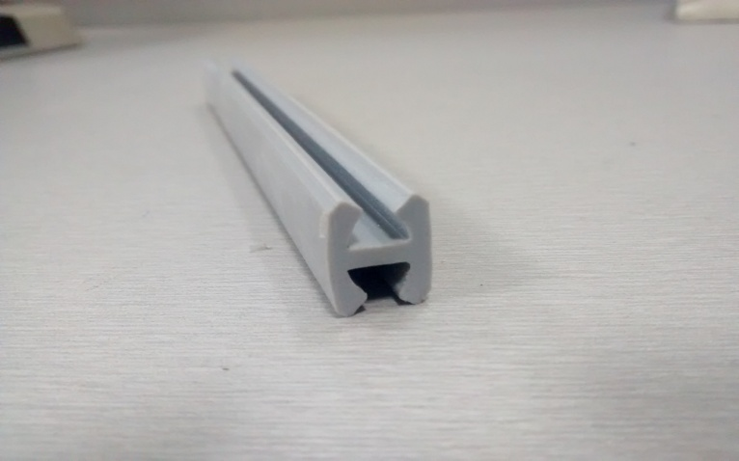

Figure 1.1

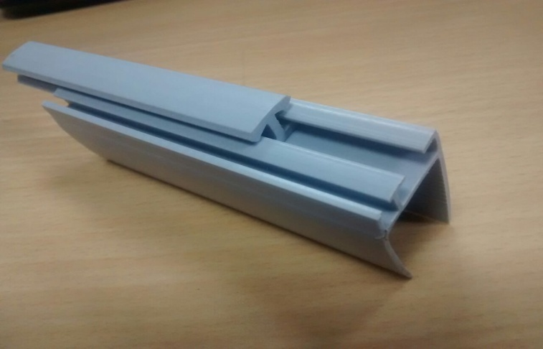

Figure 1.2

Leakage happens due to a slight dimension difference in the H Bayonet size and invisible profiles and the air may escape from that area of concern which is very crucial in clean room, classified area, Pharmaceutical, Hopsitals etc. To overcome the leakage issues and provide zero leakage systems AIPL has developed a new H- Bayonet systems with a rubber gasket(as shown in the Figure(2) below) which further enhances the rigidity of the system and reduces the air leakage factor to zero. The rubber gasket embedded in the Bayonet takes the shape of the profile in which it is inserted thus forming a layer and avoiding air escaping from the gaps.

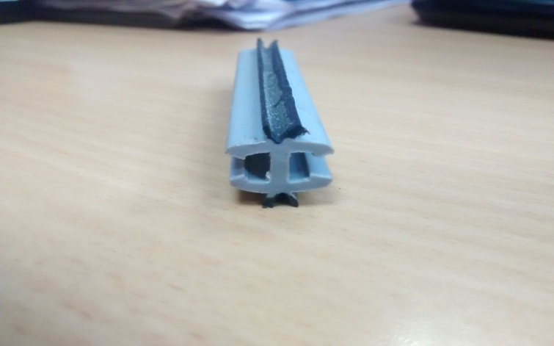

Figure 2

**New Connecting Profile(T – Connector):**

In Conventional Pre Insulated Ducting System for collars, droppers, branches etc or any other offset connection from Main line, Direct male to female connection joint(Foam to Foam) connection is done with adhesive and silicon sealant. This systems is sustainable in when the ducting is hidden above false ceiling and for areas where ducting is exposed and for industrial application where there is lot of movement that happens around the PID system the chance for the connection at branches, collar droppers might open as it is only foam based connection and the system might lose its integrity. To overcome this problem AIPL have developed a new type of connecting profile in PVC called as Tee Connector (as shown in figure below) which would now be used for connection from the mail line. The use of Tee connector provides the system with more strength and rigidity that even in the case of exposed ducting there would not be any chance of leakage due to opening on at the connection area.

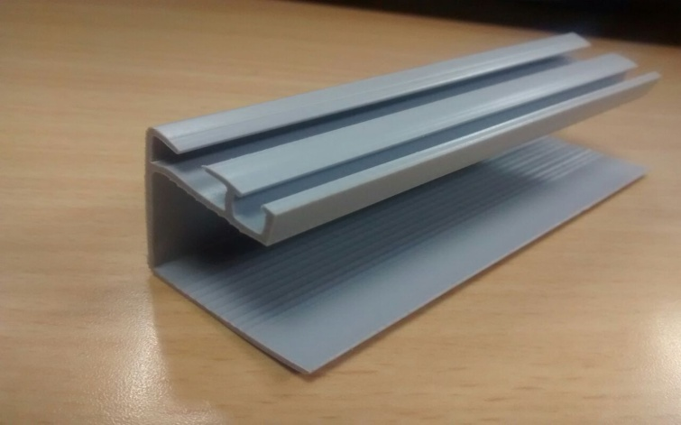

**B.SMART PRE INSULATED FLAT OVAL/ HEXAGON DUCTS:**

Introducing Pre-insulated (PIR) Flat oval and Hexagon Ducts, manufactured by AIPL at Khopoli, Maharashtra with one of the most advanced machines that can cut the sheets to form a perfect Oval and Hexagon shape as per the requirement of the clients.

This system replaces the conventional system Flat Metal Oval Duct where the production capacity constraints of the manufacturer limits Architects & Clients to use Flat oval system in projects with high volume ducting.

With the introduction of AIPLs revolutionary product, the company will not only be able to serve the clients irrespective of the size of the project but will also able to reduce the capital expenditure of the client with expert consultation on value engineering.

The added advantage of onsite installation will make it further viable due to reduced logistic cost. AIPL can thus cater to all the projects even at the remotest locations.

Installation being the critical and most challenging parameter in the segment, AIPL shall take care of the installation to meet the aesthetics and the quality as required by the client. As against the conventional system, the hanging supports of Pre Insulated Flat Oval are developed by AIPL so that the aesthetics of the project are not compromised.

**Advantages**

* In order to increase the rigidity of the Pre Insulated Flat Oval system, AIPL is introducing new type of Panel which will enhance the strength of the System.
* The coupler is designed so as to sustain both low and medium pressure airflow with leakages which are far lower than existing technologies.
* These ducts can be painted with any desired colors to match the ambience of the room. The manufactured Panels do not contain any logo on the external visible surface which increases the aesthetics of the ducts when painted. With these ducts, scope of designing will increase as the capability of manufacturer in any sizes are more as against conventional metal Flat Oval Duct.

Pictures of site given below

