**SocZen Technology Pvt. Ltd.**



**SocZen Technology Awards List:**

1. Emerging Stars Award 2023 - Social Startup by BCIC - Bangalore Chamber of Industry and Commerce

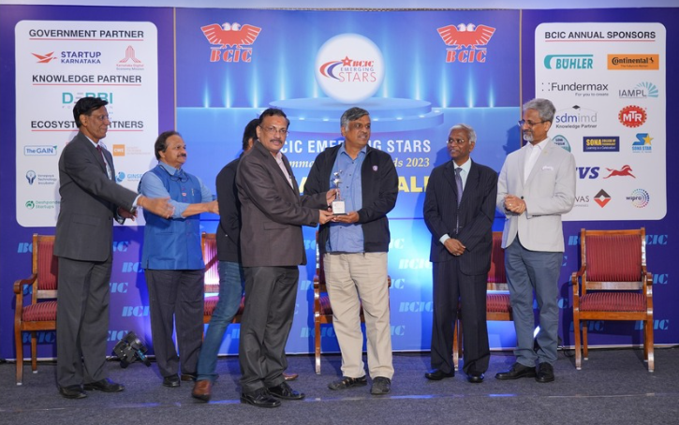

2. IDEA Award 2023 from Entrepreneur India - Best use of Technology for Social Innovation

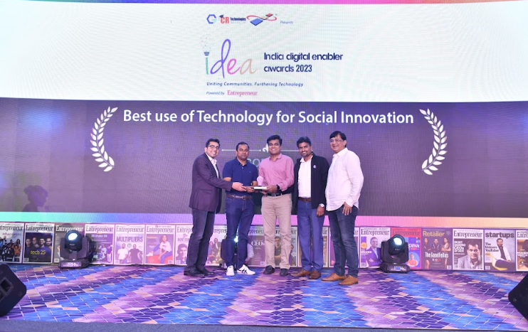

3. Indian Iconic Firm of the Year - The Best Digital Marketplace for Global Social Impact from Pride India Award 2023

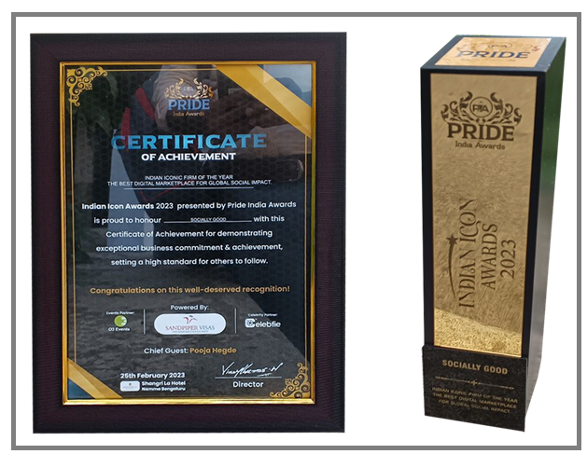

4. Star Startup Award 2022 from Ramaiah Evolute

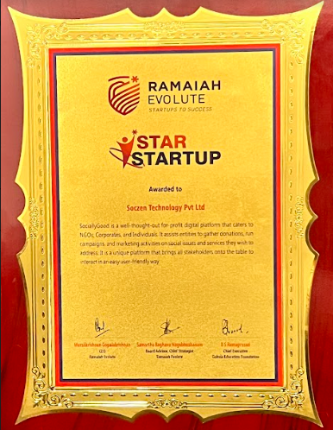

5. Winner of Elevate Karnataka 2021 from Startup Karnataka

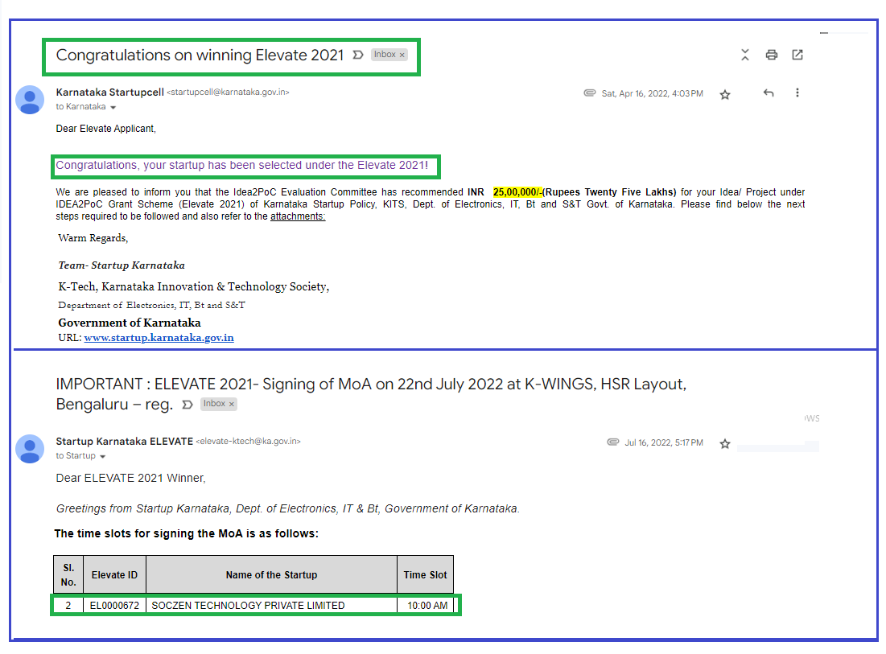

6. BW Businessworld TechTors Award 2020 winner - Tech Companies to watch out for

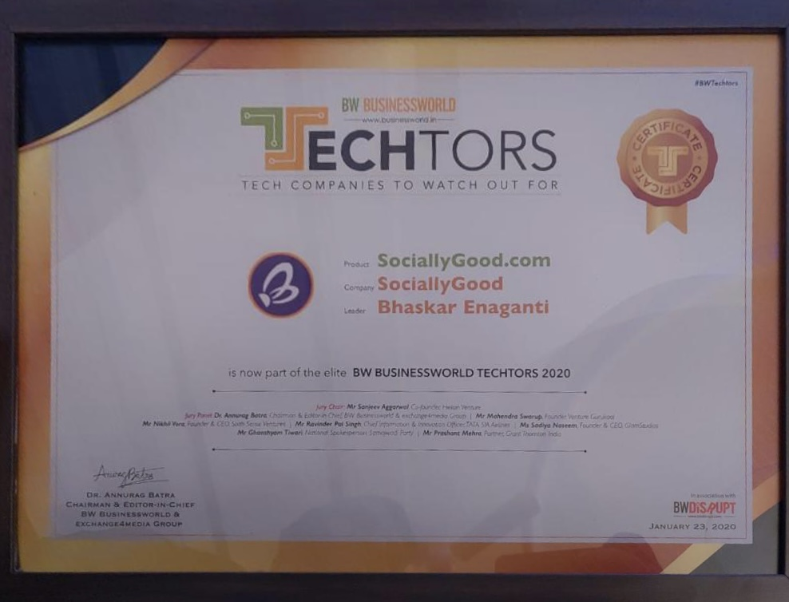

**7.** Certification of Merit from IISF 2020 (India International Science Festival)

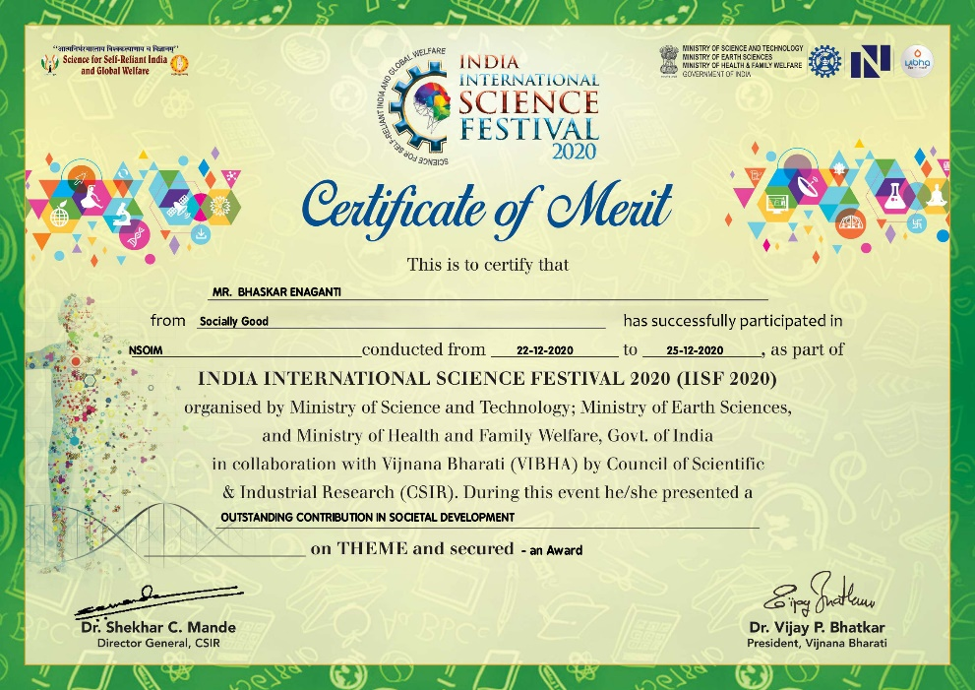

For More details: <https://www.sociallygood.com/MediaCoverage>